Chapter 17, Problem 57.

The coefficients of the trigonometric Fourier series representation of a function are:

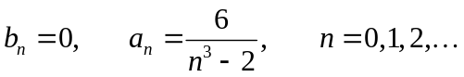

If ω_{n} = 50 n, find the exponential Fourier series for the function.

